MEAT TRAIN
Written and Directed by Adwaith Asokan

I. Something falls from the sky
During a violent monsoon Kallippara Forest, Western Ghats, a meteorite crashes deep inside the forest.
It doesn't create a massive crater. Instead, it falls into a deep limestone cavern beneath the mountains.
Inside the meteorite is a dormant extraterrestrial organism.
It isn't a conventional alien.
It is a living, symbiotic biological entity that survives by bonding with other organisms
It started multiplying to a group of organisms.
It sounded sharp like a dinosaur.
This started a haunting atmosphere in Kallippara Forest holding an evil power where danger lurks.

II. SCENE 1 — "DON'T GET OFF" (An introstory)
INT. VANDE BHARAT — NIGHT
11:56 PM
Heavy rain lashes against the windows.
The Vande Bharat cuts through the darkness of the Western Ghats.
Most passengers are asleep.
The coach is dimly lit.
At the rear of the coach, a group of four friends sit together.
Vinod — 31, drunk, loud and completely carefree.
Beside him:
Vivek — 24
Arjun — 27
Shabu — 29
A half-empty bottle is hidden beneath the seat.
Vinod is trying to open a packet of chips.
He misses.
Drops it.
VINOD
"അയ്യോ..."
Hemanth looks at him.
VIVEK
"നീ എത്ര കുടിച്ചു?"
VINOD
"ഞാൻ കുടിച്ചിട്ടില്ല."
Arjun laughs.
ARJUN
"നിന്റെ മുഖം കണ്ടാൽ തന്നെ കള്ളം പറയുന്നുണ്ടെന്ന് മനസ്സിലാകും."
Vinod points at him.
VINOD
"ഞാൻ perfectly fine ആണ്."
He tries standing.
Immediately loses his balance.
Hemanth catches him.
VIVEK
"Perfectly fine."
Vinod laughs.

CUT TO:
The train suddenly begins slowing.
WHOOOOOOOOSH.
Everyone looks toward the window.
The forest outside becomes visible in brief flashes of lightning.
Dense trees.
Nothing else.
The train slows further.
VINOD
"എന്താ ഇത്?"
SHABU
"Technical issue ആണെന്ന് തോന്നുന്നു."
The train finally stops.
Silence.
The lights remain on.
An announcement crackles through the speakers.
"Passengers are requested to remain seated. The train has stopped temporarily due to a technical issue."
Vinod looks toward the toilet.
VINOD
"എനിക്ക് മൂത്രമൊഴിക്കണം."

VIVEK
"ഇവിടെ toilet ഉണ്ടല്ലോ."
VINOD
"അത് പറ്റില്ല."
ARJUN
"എന്തുകൊണ്ട്?"
VINOD
"Fresh air വേണം."
Everyone laughs.
VIVEK
"എവിടെയും ഇറങ്ങരുത്."
Vinod ignores him.
The train is stopped in the middle of nowhere.
Rain.
Forest.
No station.
No lights except the train itself.
Vinod steps down carefully.
He looks back at the open train door.
VINOD
"രണ്ട് മിനിറ്റ്."
Arjun leans out.
ARJUN
"വിനോദേ."
Vinod turns.
ARJUN
"വേഗം വാ."
SHABU
"കാട്ടിൽ പോയി വഴി തെറ്റരുത്."
VINOD
"നിങ്ങൾ പേടിക്കണ്ട."
Vivek looks at him seriously.
HEMANTH
"അവിടെ പോകരുത്. ട്രെയിനിന്റെ അടുത്ത് തന്നെ നിൽക്ക്."
Vinod gives him a drunken salute.
VINOD
"Yes, sir."
He disappears around the side of the train.

EXT. FOREST BESIDE TRACKS — NIGHT
Vinod walks several metres away.
He unzips his pants.
Looks toward the forest.
VINOD
"എന്തൊരു കാട്..."
He finishes.
Zips up.
Starts walking back.
Then—
CLICK.
He stops.
Looks behind him.
Nothing.
Rain.
Trees.
VINOD
"ആരാ?"
Nothing.
He laughs at himself.
VINOD
"പേടിപ്പിക്കാൻ നോക്കുവാണോ?"
He starts walking.
Then hears:
CRACK.
A branch breaking.
Vinod stops again.
He looks toward the trees.
Nothing.
He pulls out his phone.
No signal.
VINOD
"അടിപൊളി."
He turns toward the train.
Vinod reaches the place where he thinks the train is.
But—
THERE IS NO TRAIN.
His drunken smile disappears.
VINOD
"എടാ..."
He looks down the tracks.
The Vande Bharat is already moving away.
Its red rear lights disappear into the rain.
Vinod stares.
VINOD
"എടാ!"
He runs.
VINOD
"Vivek!"
The train disappears around a bend.
Vinod stops.
Breathing heavily.
VINOD
"പോയോ?"
He laughs nervously.
VINOD
"ഇവന്മാർക്ക് ഇത്രയും ധൈര്യമോ..."
He takes out his phone.
Tries calling.
NO SIGNAL.
He looks around.
The forest suddenly feels much larger.
-------
Vivek looks out the window.
His smile disappears.
VIVEK
"വിനോദ് എവിടെ?"
Arjun looks toward the door.
ARJUN
"അവൻ ഇറങ്ങിയതല്ലേ?"
They look at each other.
SHABU
"ട്രെയിൻ പോയല്ലോ..."
Silence.
Hemanth immediately gets up.
VIVEK
"Emergency chain..."
A railway employee stops him.
EMPLOYEE
"Sir, please sit down. Train already moving."
VIVEK
"ഞങ്ങളുടെ friend പുറത്താണ്."
The employee's expression changes.
Vinod walks along the tracks.
VINOD
"ഹേയ്!"
No answer.
VINOD
"Vivek ?!"
Only the sound of rain.
He tries calling again.
No signal.
He looks toward the forest.
Something moves.
Very fast.
Vinod freezes.
VINOD
"ആരാ?"
Nothing.
He takes a step backward.
CRACK.
This time—
Behind him.
He turns.
Nothing.
He laughs nervously.
VINOD
"നായ ആയിരിക്കും."
Then—
A faint sound.
CLICK... CLICK... CLICK...
Like claws touching stone.
Vinod's smile disappears.
POV — SOMETHING WATCHING VINOD
We don't see the creature.
Only its perspective.
Vinod is standing in the middle of the frame.
The camera slowly moves closer.
His breathing becomes louder.
The rain becomes quieter.
Lightning flashes.
For less than a second—
We see something crouching on a tree branch.
Only half its face is visible.
One pale eye.
Wet black-brown fur.
Part of an elongated jaw.
Several unnaturally long teeth.
Then darkness.
Vinod doesn't see it.
The audience does.
THUNDER.

VINOD
He starts backing away.
VINOD
"ആരാ അവിടെ?"
Nothing.
Then—
CLICK. CLICK. CLICK.
The sound comes from behind him.
He turns.
Nothing.
The sound comes from his left.
Nothing.
Then his right.
Nothing.
Vinod realizes—
IT IS CIRCULATING HIM.
He runs.

EXT. FOREST — NIGHT
Vinod crashes through the vegetation.
Branches hit his face.
He falls.
Gets back up.
Keeps running.
Behind him—
THUD.
He looks back.
Nothing.
He runs faster.
Then—
A HAND GRABS HIS ANKLE.
Vinod screams.
He falls face-first into the mud.
He kicks violently.
VINOD
"HELP!"
The grip disappears.
Vinod crawls away.
He looks at his ankle.
Four long bloody scratches.
He tries standing.
SNAP.
Something breaks behind him.
He turns.
We hear breathing.
But not human breathing.
Deep.
Wet.
Controlled.
Vinod whispers:
VINOD
"Please..."
The creature steps forward.
We see:
one claw.
Then its shoulder.
Then half its face.
Never the entire body.
Vinod starts crying.
VINOD
"എന്നെ വിട്..."
The creature tilts its head.
Almost as if studying him.
Vinod notices something.
It is listening.
He stops breathing.
The creature stops moving.
Vinod slowly realizes:
It can hear him.
His heart pounds.
THUMP.
The creature's head moves.
THUMP.
Vinod covers his chest.
The creature takes one step closer.
Vinod suddenly screams and runs.
The creature launches forward.
We don't see the impact.
CRASH!
Vinod disappears into the darkness.
His phone falls onto the ground.
The screen remains lit.
On the screen:
HEMANTH CALLING...
The phone vibrates.
The creature slowly approaches it.
The vibration stops.
Silence.
Then—
The creature touches the phone with one claw.
The screen lights again.
CALL ENDED.
The creature lifts its head.
Far away—
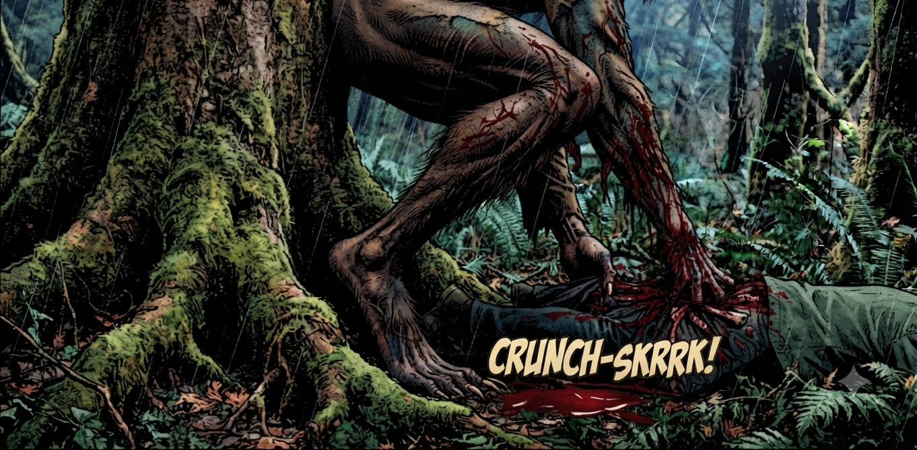
THE VANDE BHARAT'S HORN.
The creature looks toward the train.
Its pale eye catches the light.
CUT TO BLACK.
TITLE CARD – MEAT TRAIN
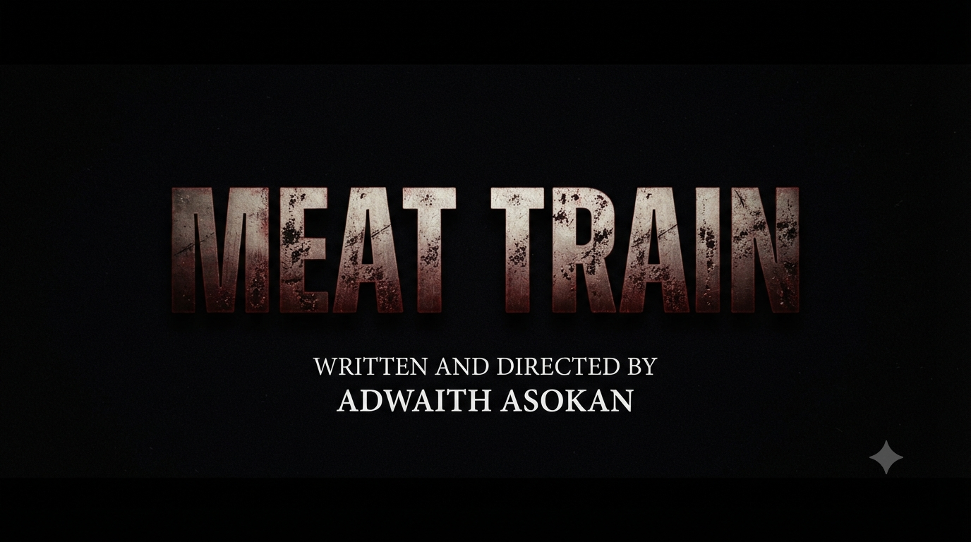
MAIN STORY
A normal rainy morning in Kochi , people are rushing to work for their respective jobs. Hemanth Viswanath, a 25yr old guy catches the exact 9am metro everyday in Kochi to see his long untold crush “Maya Prasad”. Hemanth comes from an upper middle class family ,works at a fairly good software company in Kochi, stays in a shared apartment with his friends while Maya is a Kochi Native staying with her problematic parents who are in the verge of divorce ,works in a designing company in Kochi , has only few friends.
Maya knows the fact that Hemanth has a crush on her and she wants him to take the first step and confess it. Hemanth badly wants to talk to her but is scared that she might reject him.

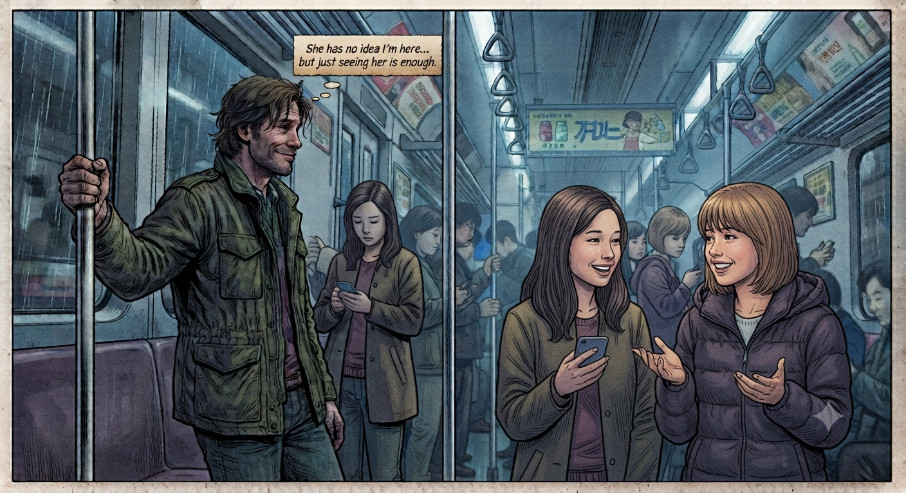

Hemanth lives with his friends Jerry and Kiran. They always encourages him to talk to Maya especially Jerry. Jerry always teases him saying that
“നീ കുറച്ചു നാളയല്ലോ അവളോട് പറയണം എന്ന് പറഞ്ഞു നടക്കുന്നത് ,വല്ലതും നടക്കുവോ ?”
It has become a routine for Jerry to be at 9am metro everyday and fail at approaching her. His attitude is that
“ ഇന്ന് പറയണ്ട... നാളെ പറയാം "
Maya on other hand wants him to approach her but thinks that he isn’t capable. Maya’s friend Dona who works in the same company as her, travels with her in metro daily teases Maya saying that
“നിൻ്റെ അത്ന്യാത കാമുകൻ അവിടെ വന്ന് നിൽക്കുന്നല്ലോ
പതിവു പോലെ പാവം ഇന്നും നിന്നോട് മിണ്ടാൻ പേടിച്ച് നിക്കും”
Days passed by and he still haven’t confessed. Hemanth’s friends are very supportive and they helps him collecting information about her. Hemanth through his friends, got to know that Maya is leaving to Kozhikode alone for visiting her relatives. He thinks that this is the best chance to confess his love for her.

